Presentation and Discussion Paper

Pampel, Fred C. 1998. “National Context, Social Change, and Sex Differences in Suicide Rates.” American Sociological Review 63 (5): 744–58. https://doi.org/10.2307/2657337.

I. Background (Siming)
1. considerable disagreement exists over the meaning of the sex differential in suicide rates.
a. Gender inequality may protect women from suicide.
· Reduction-in-protection theory: The movement toward social equality increases the suicide rate of women relative to that of men.
· This argument predicts convergence over time in male and female suicide rates associated with greater equality of social roles.
b. If forces other than status differences produce the sex differential in suicide rates, gender inequality may attenuate female advantage.
· Reduction-in-inequality theory: unequal benefits of marriage to men and women and the limited roles reserved for women in the past have attenuated the potential female advantage in suicide rates.
· These arguments predict divergence over time in male and female suicide rates associated with greater equality of roles in the family
c. combines the reduction-in-protection and reduction-in-inequality arguments by suggesting that processes of both convergence and divergence in these rates occur in sequence.
2. Purpose of this study: (Siming)
Examine a hypothesis of institutional adjustment in which the sex differential in suicide rates first narrows and then widens with continued societal change.

3. Argument: (Siming)
Among high-income nations, the degree of institutional adjustment varies with national context. All countries may experience the curvilinear pattern of change posited by the institutional adjustment argument, but adjustment occurs more quickly among nations with collectivist rather than individualist institutions of social protection.

II. Method & Descriptive Results (Analytical strategy)
- Description of data
The number of observations considered in the dataset used by the author is 5,040. The author considered a sample of 18 high-income per capita countries with more than 1 million inhabitants and a temporal scope of 40 years from 1953 to 1992 by 7 age-group categories. N=5040, all of them with variation in the suicide rates by gender as a dependent variable.
But, only 720 cases have separated values in the independent variables: female labor force participation rate, divorce rate, marriage rate, fertility rate, Real GDP per capita, and collectivism, because there is no variation of those independent variables among the seven Age-groups of the same country-year.

- Description of the sample (who is the eligible sample?).

Countries with high-income per capita and >1 Million inhabitants (18) * Years between 1953 and 1992 (40) * Age-groups (7) = 5040 cases

$$5040 =∀(countryyearage): Δ(suicides rates gender ratio)$$

$$720=∃(countryyearage):¬Δ(female labor force participation rate,$$
$$divorce rate, marriage rate, fertility rate, Real GDP per capita, collectivism)$$

- Description of your Measures: Dependent variables, Main Independent variables, and Sociodemographic controls, Other Controls.

The analysis takes sex differentials in suicide rates controlled by country, year, and age group as the dependent variable.

The sources for data collection on the dependent variable is the reported age-specific and cause-specific mortality data for males and females of the National Center for Health Statistics and the WHO.
$${suicides_sex_rate}_{sex, age-group}=\frac{\sum{{suicides}_{sex, age-group}}}{{100000}_{sex, age-group}}$$

The measure of the difference between the suicide sex rates by age groups as the suicide sex ratio is calculated as the deviation of the actual value of the ${suicides_male_rate}_{ age-group}$ from its expected value: $\hat{{suicides_male_rate}_{ age-group}}$, given an specified ${suicides_female_rate}_{age-group}$ and the coefficient of General Linear Regression (GLS) between male ${suicides_male_rate}_{ age-group}$ and female suicide rates ${suicides_female_rate}_{age-group}$ . This measure is labeled by the author as residual-based because its comparing ${suicides_male_rate}_{ age-group}$ with ${suicides_female_rate}_{age-group}$ on the basis of a normative standard, in this case defined by the average difference between them
$\frac{\sum{{suicides_male_rate}_{ age-group} -{ suicides_female_rate}_{ age-group}} }{N}$ .

The main independent variables considered for the analysis were:

$$female labor force participation rate, divorce rate, marriage rate, fertility rate,$$
$$Real GDP per capita, collectivism$$

$${female labor force participation rate}_{country,year}=\frac{\sum{{female labor force}_{country,year}}}{{female population}_{country,year}}$$

$${divorces rate}_{sex,country,year}=\frac{\sum{{divorces}_{sex,country,year}}}{{1000 population}_{country-year}}$$

$${marriages rate}_{sex,country,year}=\frac{\sum{{marriages}_{sex,country,year}}}{{1000 population}_{country-year}}$$

$${fertility rate}_{country,year}=\frac{\sum{{female population of childbearing age}_{country,year}}}{female {population}_{country-year}}$$

Real GDP per capita, as a trend variable

Collectivism index: corporatism, consensus government, years of leftist rule, universalism in public benefits, absence of violent political conflict, as a contextual indicator to assess the impact of the political and economic environment on the adjustment of male and female suicide rates to social change.

- Descriptive statistics table

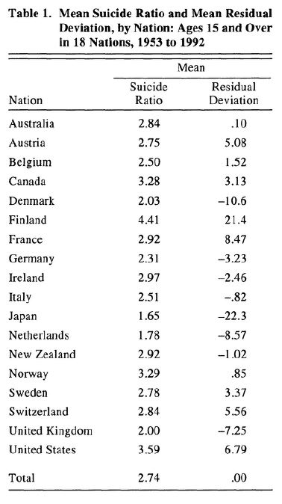
The suicide rate for males averaged over the 40 years and 7 age-groups is always greater than the averaged suicide rate for females in every country of the sample.
This is highlighting the preponderance of male suicide rates expressed in:

${suicides ratio}_{country}=\frac{{suicide male rate}_{ country}}{{ suicide female rate}_{ country}}>1$,

if: $suicide male rate>suicide female rate$

The residual deviations expressed the same pattern as the suicide ratio.

$${residual deviations}_{country}=\frac{{suicide male rate}_{ country}}{{ suicide female rate}_{ country}}$$

Positive scores indicating more male suicides than female suicides by country.
Negative scores indicated more female suicides relative to the average or standard of the country.

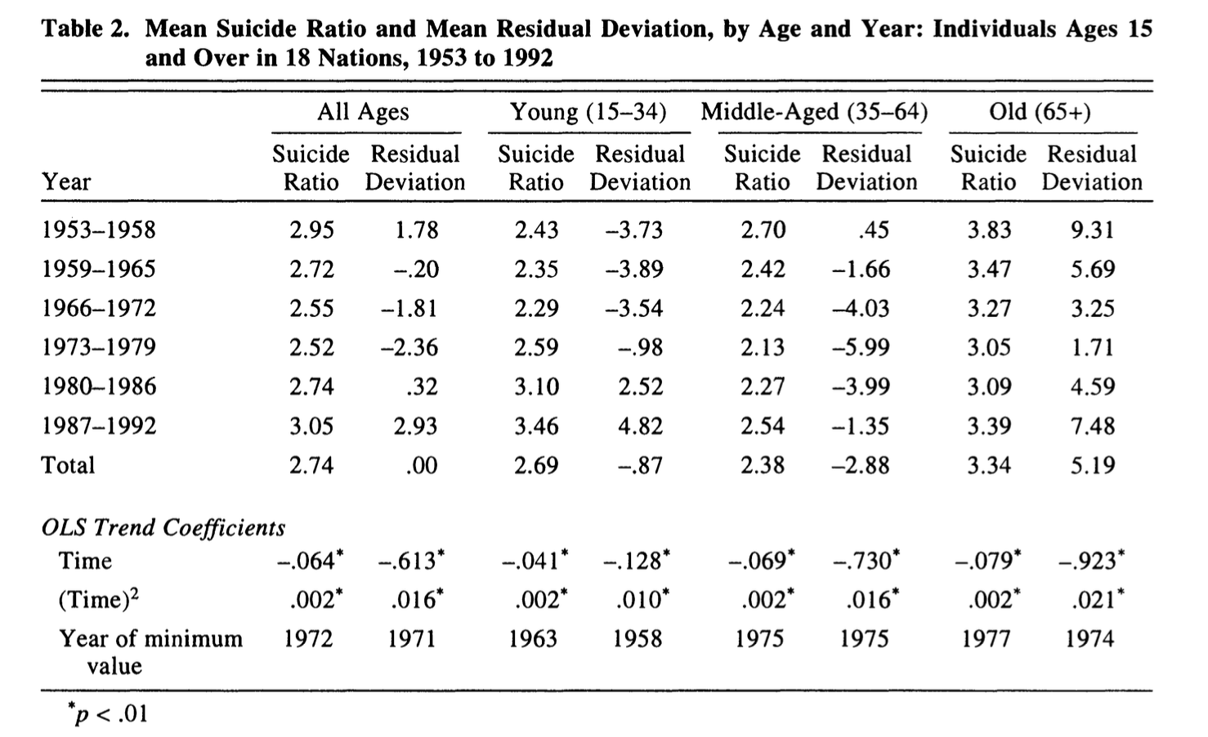

The Table 2 expresses an initial decline on the coefficient of Time and Time square and an increase of its effect on suicide rates after 1971, before that year female suicide rates diminished faster than male suicide rate, but after 1972 male suicide rates increased faster than female ones.

III. MULTIVARIATE RESULTS

Why modeling nonlinearity?

For the suicide ratio and the residual deviation, the unstandardized coefficient for time has a negative sign (-.064 and -.613, respectively), and the unstandardized coefficient for time squared has a positive sign (.002 and.016, respectively).
Y = A* x² +B*x
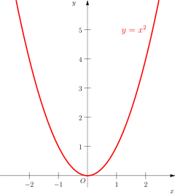

These coefficients indicate an initial decline and then an increase in the sex differential in suicide rates

- The time trends differ when considered separately within three broad age groups.
  - The mean suicide ratio and residual deviation for young, middle-aged, or old age groups (15-34, 35-64, 65 and over) show a decline and then an increase.
  - However, the age groups differ in the time of adjustment. The differentials bottom out early among the young; around 1960, male suicide rates begin to rise faster than female suicide rates.
- The sex differentials in suicide rates for middle-aged persons:
  - shift direction in the mid-1970s, while the suicide ratio for older persons does not shift direction until 1977.
  - Consistent with predictions, female suicide rates relative to male suicide rates rise and then decline for all age groups, but shift direction earlier for younger persons

- Additive Effects
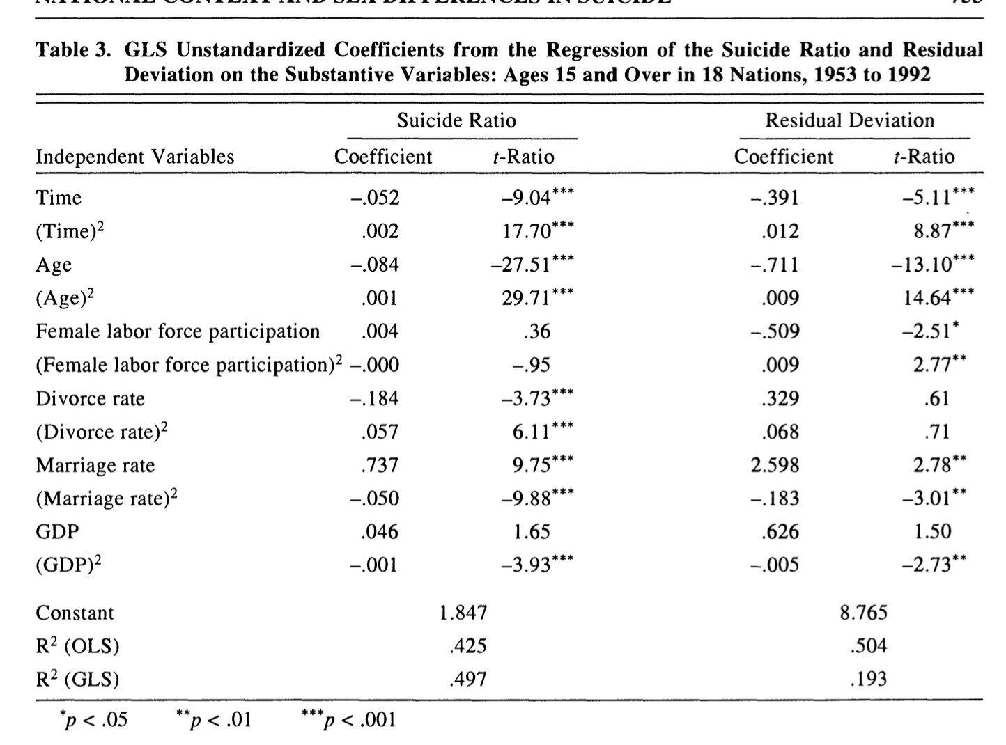

Next, I examine the effects of the substantive variables on sex differentials in suicide
rates net of the influence of the nation, time, and age variables that structure the data.
Table 3 presents multivariate results for time, age, and four time-varying substantive variables - the female labor force participation rate, the divorce rate, the marriage rate, and real gross domestic product per capita.
Treated as second-order polynomials, the variables can capture the nonlinearity specified by the institutional adjustment hypothesis.

- Most, but not all, of the variables in the multivariate equation show the curvilinear coefficients predicted by the institutional adjustment hypothesis.
  - As indicated by the negative and positive coefficients for time and time squared, the female advantage in suicide rates first declines and then rises.
  - Across ages, the female advantage in suicide rates drops from youth to middle age, but then rises again in old age.

- Of the substantive variables, the marriage rate most consistently relates nonlinearly to the sex differentials in suicide rates and most clearly supports the institutional adjustment hypothesis.
  - Because the marriage rate declines over time, it has a positive coefficient for the unsquared term and a negative coefficient for the squared term;
  - a declining marriage rate initially lowers the female suicide advantage but later increases it.
- The female labor force participation rate and the divorce rate support the predictions for only one of the dependent variables.
  - For the female labor force participation rate and the suicide residual deviation, the negative coefficient for the unsquared term and positive coefficient for the squared term indicate that as the female labor force participation rate initially rises, the female suicide advantage narrows, but as participation continues to rise, the female advantage increases.
- For the divorce rate and the suicide ratio, similar coefficients reveal that rising divorce rates initially contribute to equality in male and female suicide rates but later contribute to the female advantage.
- The total fertility rate had no influence net of the marriage and divorce rates and thus is excluded from the equation.
- Finally, the coefficients for GDP demonstrate a dominant negative effect. Net of the time trend, rising income reduces the female suicide advantage without reversal.

- National Differences

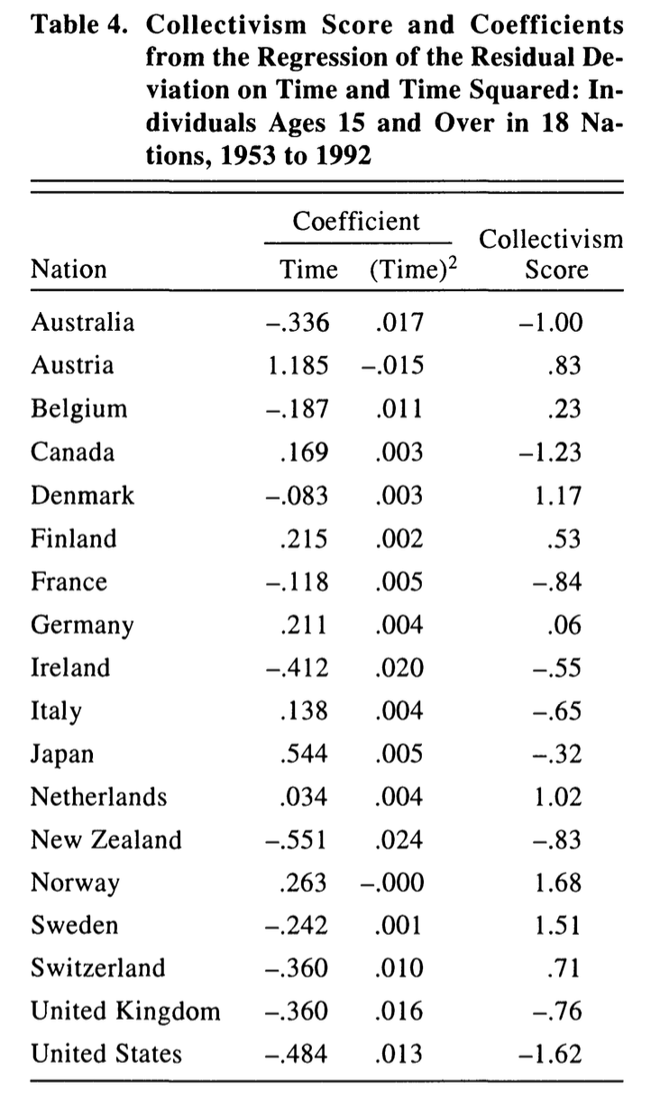

- A negative coefficient for time and a positive coefficient for time squared indicates, in rough terms, an initial decline in excess male suicide deaths that eventually becomes an increase.
- Such a pattern of coefficients appears for Australia, Ireland, New Zealand, the United Kingdom, and the United States- all nations that have low collectivism scores.

- Positive coefficients for time indicate no decline in excess male suicides and general growth of the female advantage over the full-time span.
- Nations with high collectivism scores-Austria, Finland, the Netherlands, and Norway show such a pattern.

- Although several nations (particularly Sweden, Japan, and Canada) deviate from the expected patterns for collectivist and individualist nations, a tendency exists for different trends in the relative female advantage in suicide rates to emerge for the two types of nations.

IV. CONCLUSION (Siming)
This study provides support across a variety of nations, time periods, and age groups for the institutional adjustment hypothesis. Changes in women’s roles may initially produce higher female suicide rates, but the adjustment of institutions to those changes eventually reduces relative female suicide rates to previous levels. The institutional adjustment hypothesis predicts curvilinear effects of time, female labor force participation, and divorce or nonmarriage on relative suicide rates.

